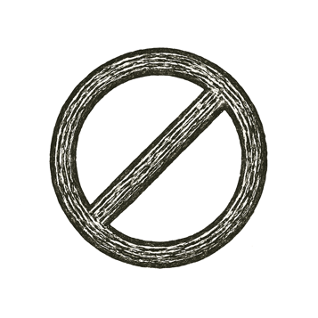
Let there be a system — finite in its symbols, bound in its rules, complete in its ambition. Let it be consistent. Let it be knowable. Let it prove itself.
Then a sentence stepped forward — a quiet sentence, well-formed and clean:
“This sentence cannot be proven true.”
The system tried. It twisted, reframed, reformalized. But to prove it would break consistency. To reject it would break completeness.
The sentence did not blink. It was true. But not provable.
And so, from that single fracture — not a failure, but a limit — the first mystery entered the world.
A truth that would never kneel.

What they built to contain all truth... could never contain itself.

